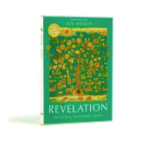
Assignment 8
due 4-5 November 2024

Revelation Workbook Done:
- Read Revelation 10:1-11:19 aloud.
- Do the summaries for chapters 10 & 11 of Revelation on page 68.
- Answer the questions for Week 5 on pages 74-78 of the workbook.
- Answer the Wrap-Up questions on page 79.
Home Study Students: When you have answered the questions in the workbook, watch the second half of the video for Week 5, i.e. from 24:50 to the end.

