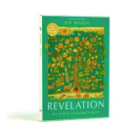
Assignment 3
due Sep.30 / Oct.1, 2024

Revelation Workbook Done:
- Read Revelation 4:1-11 aloud.
- Answer the questions for Week 3 on pages 35-42 of the workbook.
(Note for page 36: Just do the summaries for Revelation chapter 4.)
Home Study Students: When you have answered the questions in the workbook, watch the first half of the video for Week 3, i.e. from the beginning to about 26:43.

